ACSL
American Computer Science League
2012 - 2013

Contest #1

Classroom Division

1. Recursive Function
Find (100) given:
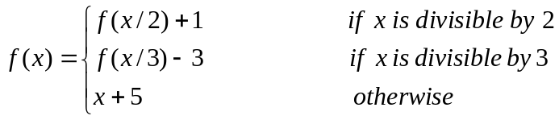

- Recursive Functions
Find (1,10) given:
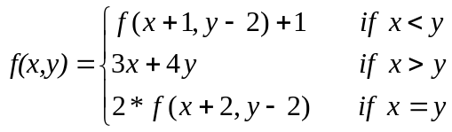
3. Computer Number Systems
Express the difference in hexadecimal.
DEAF₁₆ - ACED₁₆

4. Computer Number Systems
Convert to octal.
FACE₁₆

- What Does This Program Do?
What is printed when this program is run?
a = 20: b = 5: c =2
d = a / b
e = c ^ 2 * a / b
if e > a then a = e - a
if d / 2 = int(d / 2) then b = a / c
if b = e then e = e - 2 else b = 2 * b
if d * c < a * b then a = d - c else c = d + c
print (c + d)/a - b/a + e
end

ACSL
American Computer Science League
2012 - 2013

Contest #1

Classroom Division

6. Recursive Functions
Find (16) given:

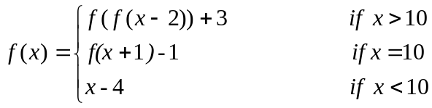
Where [n] represents the greatest integer ≤ n
7. Recursive Functions
Find (10,3) given:
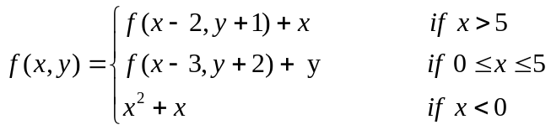

8. Computer Number Systems
Which number is the largest?

2A3₁₆ 1243₈ 678₁₀ 1010100101₂

9. Computer Number Systems
Evaluate the following expression and express the answer in octal:

101101₂ * B7₁₆

10. What Does This Program Do?
What is printed when this program is run?
a = 10:b = 8:c=2:d=-1:e=0
if (a+2)/(b-2)= c then a = a + b
if a + c - 8 < e then c = c + b else e = e + b
if b*c > d^2*e/b then d = d * c else d = d * d
if a + c + d = b + e then c = a - d else b = a + b / 2
if e - d <> a + c then e = e / c else c = c ^ e
if (a>b) and (b>c) then a = b - c
if c / 2 = int (c / 2) then c = c / 2
print (b + d) / e + ( a + e) / b + c
end

